📘 Neural Networks, and Matrix Shapes

1. Core Idea
- Every neuron computes:
z = w·x + b
(dot product of weights and inputs + bias).
- Confusion comes from notation flips:
  - Math textbooks vs programming libraries (row vs column convention).
  - Regression (1 neuron) vs NN layer (many neurons).

2. Terminology
- Sample = one data point (row in dataset).
- Feature = one input variable (column in dataset).
- Neuron = one unit in the current layer.
- Pre-activation (Z) = raw weighted sum before activation.
- Activation (A) = output of the layer after applying activation function.

3. Regression Setup (special case of NN with 1 neuron)
y = Xw
- X ∈ ℝ^(n_samples × n_features)
- w ∈ ℝ^(n_features × 1)
- y ∈ ℝ^(n_samples × 1)
✅ Each sample (row of X) is dotted with the weight vector w.
✅ Produces one prediction per sample.

4. Neural Network Layer
Z = XW + b
A = σ(Z)
- X ∈ ℝ^(n_samples × n_inputs)
- W ∈ ℝ^(n_inputs × n_neurons)
- b ∈ ℝ^(n_neurons)
- Z, A ∈ ℝ^(n_samples × n_neurons)
👉 Each row of Z = values of all neurons for one sample.
👉 Each column of Z = one neuron’s values across all samples.

5. Single Sample vs Many Samples
- One sample (row vector):
X: (1 × n_inputs) → Z: (1 × n_neurons) (row vector).
- Batch of samples:
X: (n_samples × n_inputs) → Z: (n_samples × n_neurons).
✅ Same formula works — one row = one sample.

6. Convention Flip
- Math-classroom (your image):
z = W·a + b, where W: (n_neurons × n_inputs).
- Programming (NumPy / PyTorch):
Z = XW + b, where W: (n_inputs × n_neurons).
✅ Both describe the same dot products, just transposed.

7. Forward Pass Through the Network
For an L-layer neural network (ignoring biases for simplicity):
- Layer 1:
Z[1] = XW[1] + b[1], A[1] = σ(Z[1])
- Layer 2:
Z[2] = A[1]W[2] + b[2], A[2] = σ(Z[2])
- Output Layer (regression case):
Z[L] = A[L-1]W[L] + b[L], A[L] = Z[L]
(identity activation for regression).

8. Intuition for Z and A
- Z[l] = the raw input into neurons of layer l (pre-activation).
- A[l] = the output values after activation.
Flow:
A[0] = X → (Z[1], A[1]) → (Z[2], A[2]) → … → A[L]
✅ Z feeds into activation → A.
✅ A becomes the input for the next layer.

9. Dot Product Cheat Section

Weighted Sum View
x·w = Σ (xᵢ wᵢ)
- Each feature multiplied by its weight, summed.
- Neuron computation perspective.

Alignment View
x·w = ||x|| ||w|| cos(θ)
- Geometric meaning = how much two vectors point in the same direction.
- Neuron = detector of alignment with its weight vector.

Connection
- Same operation.
- Weighted sum = practical view for coding.
- Alignment = geometric intuition for learning/classification.

10. Practical Rule (never get lost again)
- Always stick to programming convention:
Z = XW + b
- Rows of X = samples.
- Columns of X = features.
- Columns of W = neurons.
- Each row of Z = all neuron values for one sample.

⚡ Ultimate TL;DR
- Regression = 1-neuron network.
- Neural net layer = many neurons at once.
- Z = pre-activation (raw weighted sum).
- A = activation output (input to next layer).
- Dot product = weighted sum and alignment.
- Stick with Z = XW + b → works for one sample or many.

Backpropagation calculus: https://www.youtube.com/watch?v=tIeHLnjs5U8
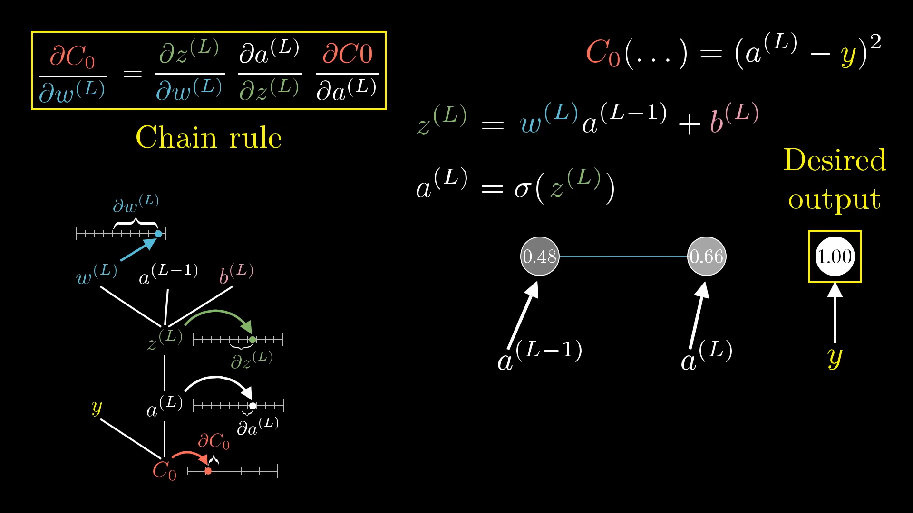
Here we see how a change in w(L) causes a change in the Cost Function and how it is calculated.
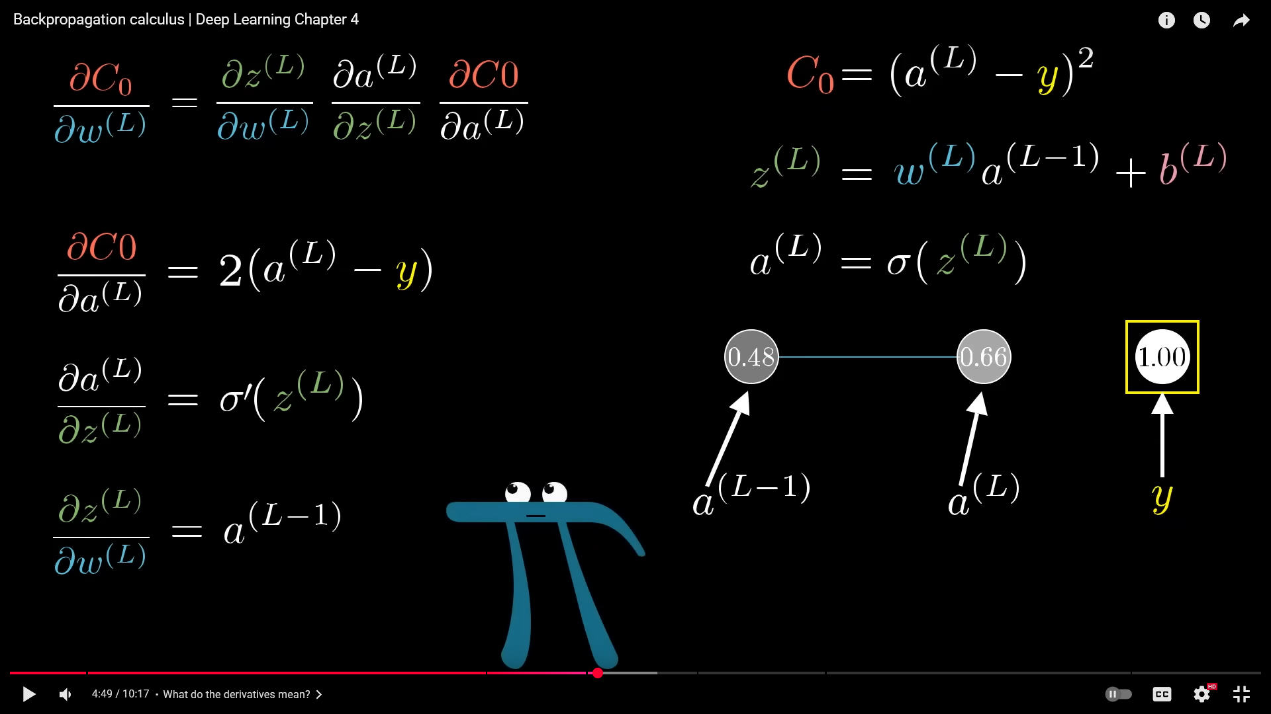
This w(L) is not the only part of the gradient calculation, we want to also calculate how a change in biases or activations changes it.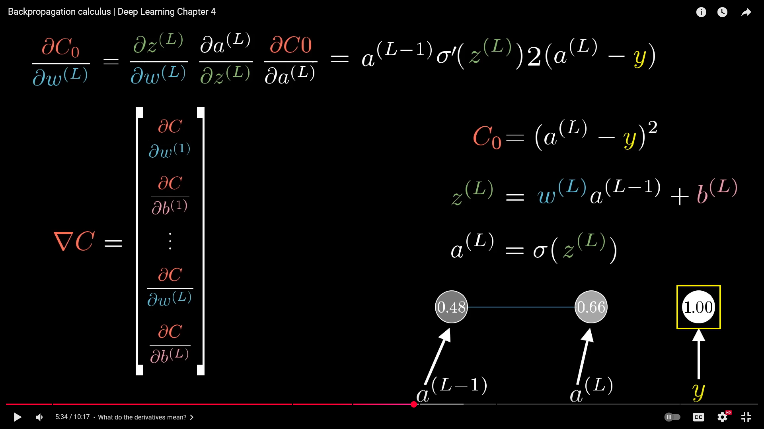
For a bias: 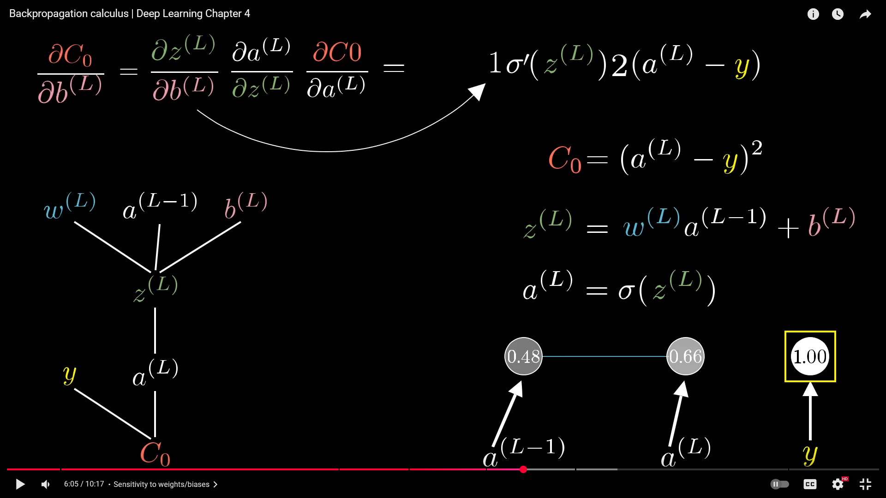
For the activation:
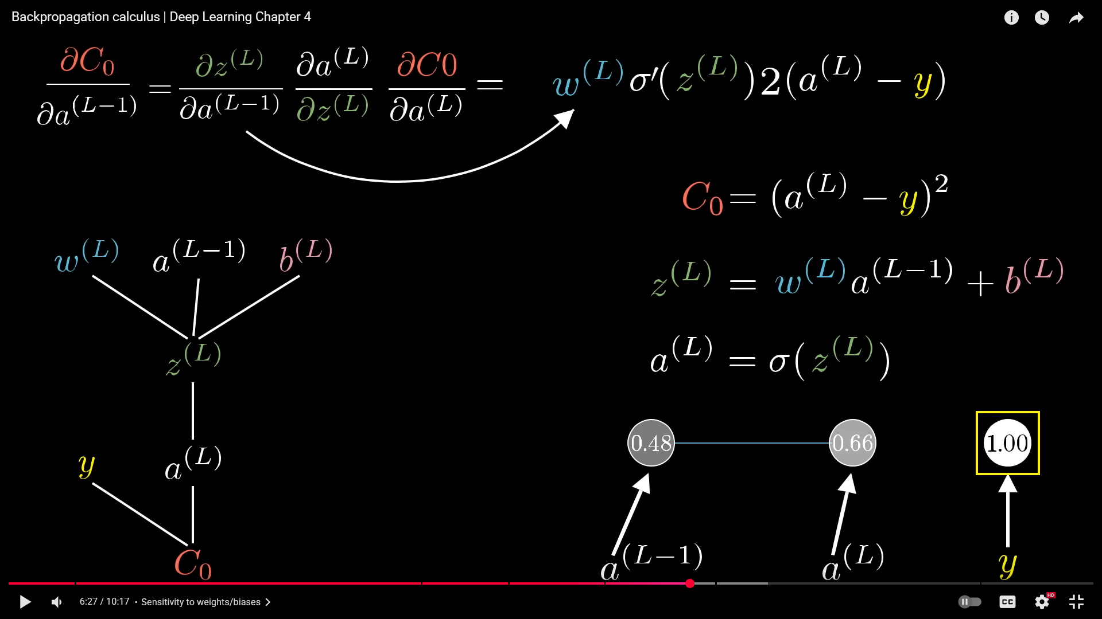
For non single neurons:
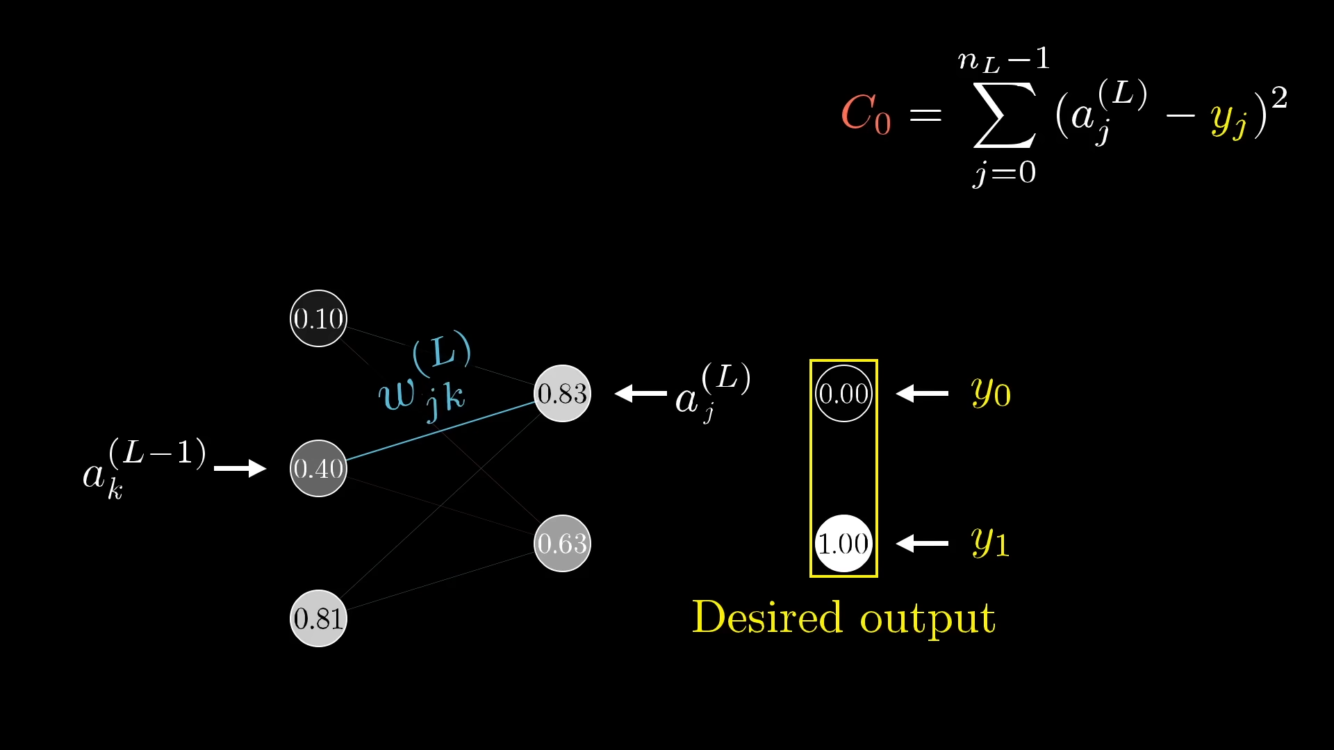

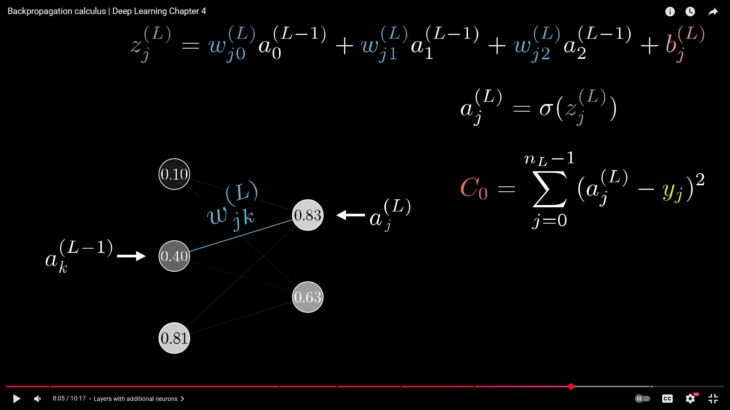
The idea is the same almost: 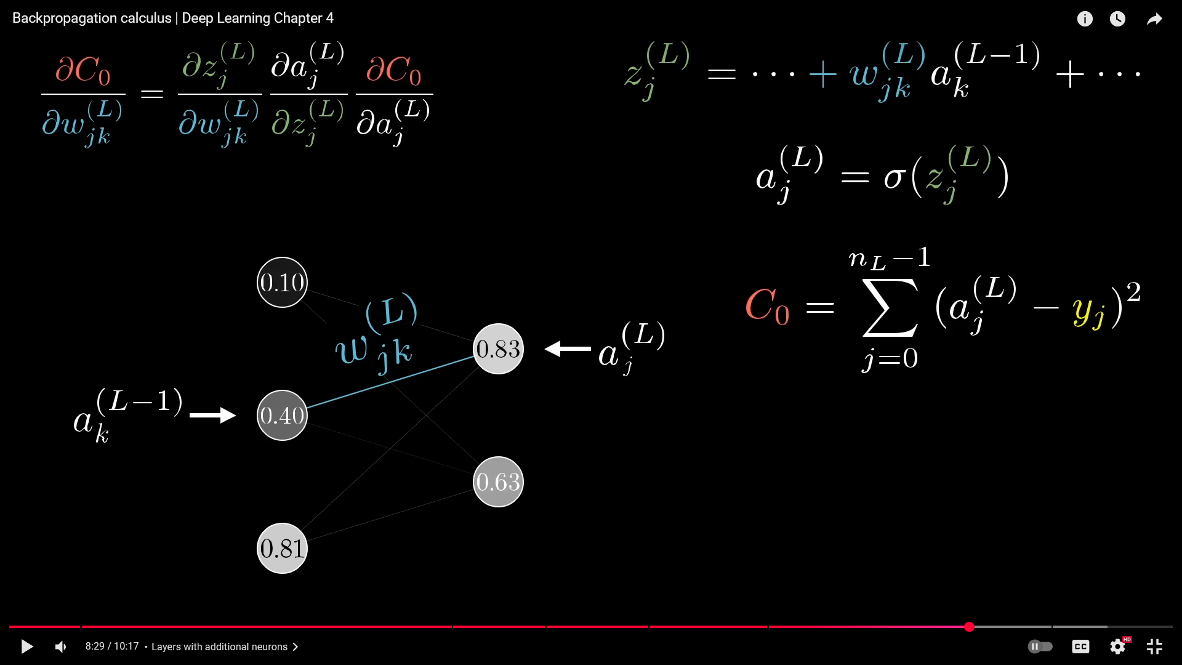
Where we use the chain rule but it’s just a bit more complicated since more nodes.
The only change is in the partial derivative of the cost wrt the activation:
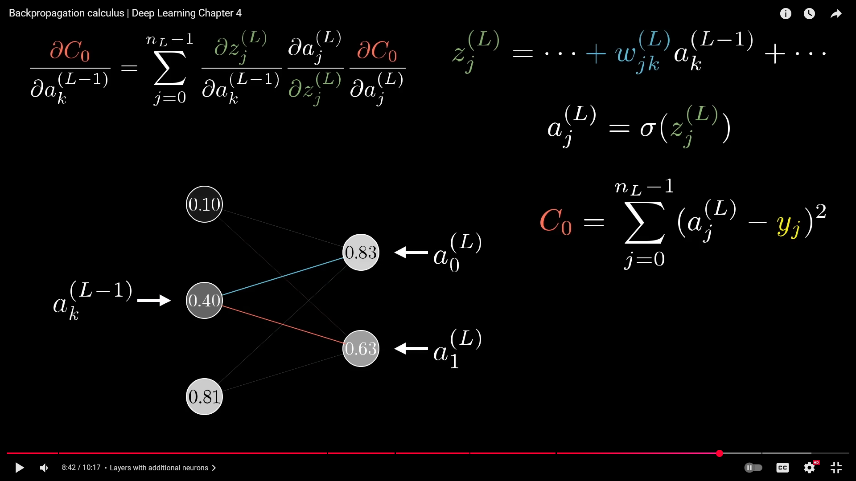
The difference is that the activation influences not only one single neuron but all neurons in the next layer. So you sum over the layer L!

